# ACA assignment 2

Lei jin

Zhonglin Nian

Plots of several feature space

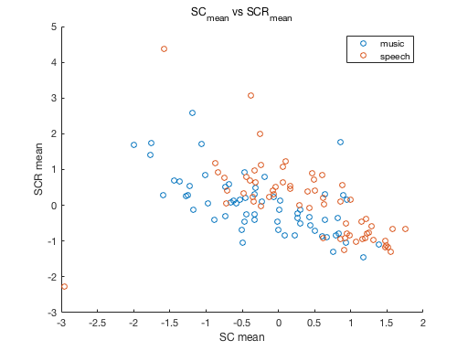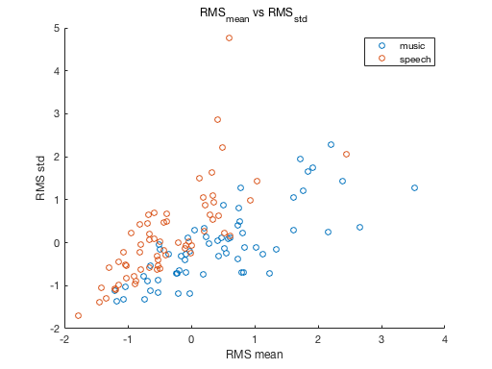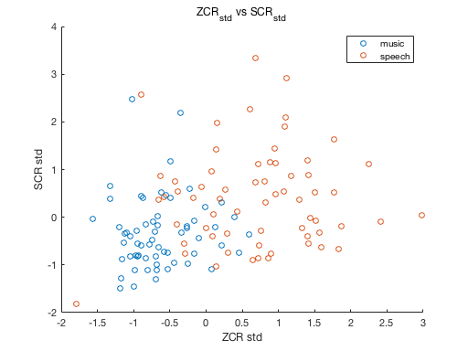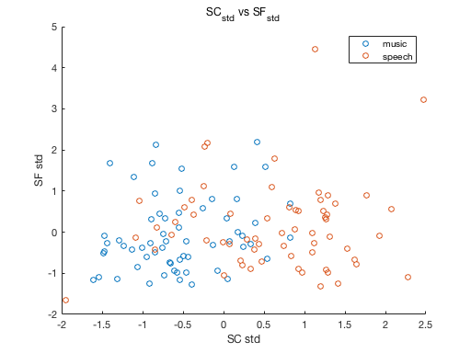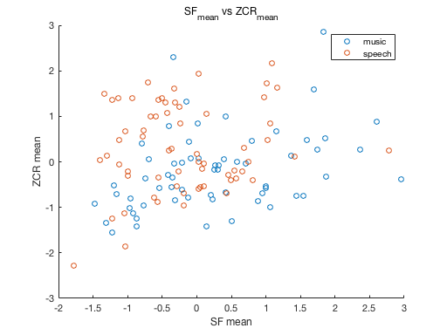

overall:

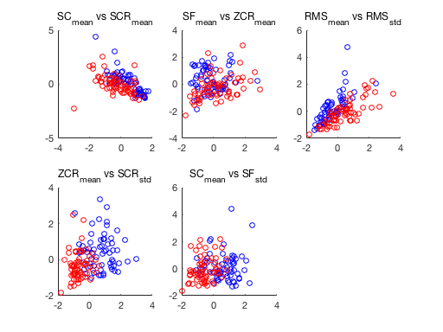

For some plots, the feature points are just messy, but if we look at plot of RMS_mean and RMS_std, speech data points and music data point can be separate nicely by just fitting a line, which can be intuitively explained that for music, the intensity should roughly be the same over time, but for speech, there are significant pauses that increases variance.